Circular Economy and Waste Strategy
- Introduction
The University of Birmingham (UoB) is committed to embedding sustainability across all areas of the organisation. As a core pillar of the University’s 2030 Strategic Framework, sustainability is a priority that shapes decision-making in our research, education and operations.
A key part of this is transitioning towards a circular economy, an approach which keeps resources in use for as long as possible, reduces waste, and maximises the value of materials. Improved management of our resources and waste will support this transition, through prioritising the principles of the waste hierarchy: reducing waste at source, enabling reuse and repair, maximising recycling, and ensuring any remaining waste is managed through recovery, with disposal as a last resort.
This Circular Economy and Waste Strategy (the Strategy) sets out how UoB will transition from a linear model of ‘take-make-waste’ towards a circular approach, embedding circular economy principles alongside effective waste management. By adopting circular economy principles and using resources more efficiently, we can deliver a range of co-benefits, including reduced environmental impact, avoided costs and strengthened resilience.
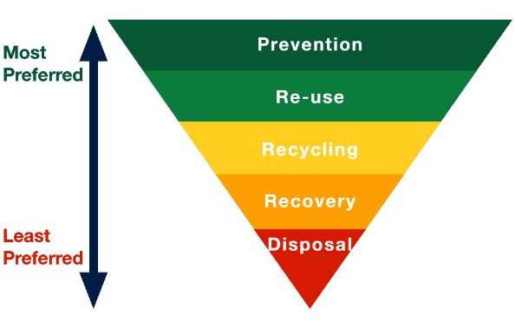
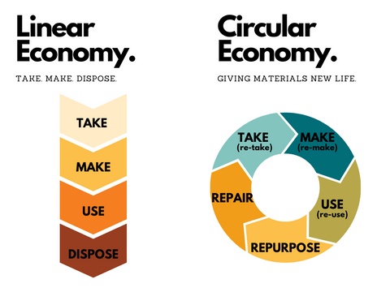
Figure 2: Linear economy vs. circular economy

Figure 1: The waste hierarchy

- Scope & Approach
This Strategy applies across all UoB activities, covering academic departments and colleges, research and operations. Delivery will rely on collaboration across the University, including professional services, academic staff and researchers, and students. This approach will strengthen connections between academic and operational activity, enabling research and practice to inform one another, and guiding UoB’s transition to a more circular economy.
The Strategy aligns with UoB’s wider strategic priorities, including the 2030 Strategic Framework, as well as its financial aims, by promoting efficient and responsible use of resources, ensuring we spend wisely and maximise the value and lifespan of assets. It also aligns with existing targets set out in the Carbon Management Plan and will support the delivery of waste-related objectives, including achieving a 40% reuse/recycling rate by 2030. As well as this, it reflects key external drivers, such as:
- Sustainable Development Goals | - The Environment Act 2021
- Concordat for the Environmental Sustainability of Research and Innovation Practice | - West Midlands Combined Authority Circular Economy Roadmap
- Simpler Recycling reforms
This Strategy sets out cross-cutting aims for delivery through to 2030. These aims will guide implementation and inform the development of a supporting action plan, which will detail specific actions, targets, and measures of progress.

- Governance
The Director of Facility Services and Sustainability Manager (Circular Economy) will oversee this Strategy, supported by the Circular Economy Action Group (CEAG) and Sustainability Steering Group (SSG). As waste management sits within the remit of Campus Services, this department will play a central role in driving the implementation and coordination of delivery across UoB.
Progress will be monitored through regular reviews, ensuring the Strategy remains fit for purpose and incorporates evolving data, legislation and opportunities.

- Baseline – Where we are now
UoB has already made progress in embedding more sustainable and resource-efficient practices across its activities. Foundations are in place across many areas, with a range of initiatives supporting waste reduction, reuse, and more circular approaches within academic, research and operational areas.
In line with the waste hierarchy, UoB prioritises waste prevention and reuse wherever possible. Where this is not feasible, materials are managed through established waste management systems, including recycling and recovery, via central contracts.
Some examples of our current activity and achievements are as follows:
- Zero waste sent to landfill from centrally managed waste streams
- Over 30 tonnes of items have been reused through WarpIt to date, saving over £250,000
- Annual Junkbusters events which have raised over £181,000 for charities since 2011
- Encouraging reuse through the UniGreen scheme, which has seen 1,086 items rehomed, generating £39,000 in rebates
- Introduction of food waste collections across accommodation and campus
- Supporting waste reduction, reuse and repair projects through our Sustainability Fund
- Improving sustainability in labs through our Green Laboratory Accreditation
- Circular schemes supported by the Technical Academy and Sustainability Champions Network
Reducing waste at source remains a primary objective for UoB, and this is reflected in the overall decrease in total waste generation over the last couple of years. This positive trend will continue to be a key focus through improved resource efficiency and prevention. However, recycling rates have also decreased over the same period. Improving reuse and recycling performance therefore remains important, with continued efforts to increase reuse and recycling to achieve our 40% target by 2030.

Figure 3: Total waste generation (tonnes) and recycling rate for 2023/24 and 2024/25
Note: Reuse activity is not yet captured within this reporting but will be incorporated where possible as data availability improves.
While this progress provides a strong foundation, activity to date has often been delivered through individual initiatives rather than a coordinated, whole system approach. This has resulted in varied practices across UoB and missed opportunities to scale successful activity. Data limitations also mean that understanding current performance and identifying opportunities for improvement can be challenging.
This creates an opportunity for the Strategy to better connect initiatives, establish our expectations and encourage a more coordinated approach. Increasing awareness and engagement across the UoB community will also be key to embedding circular practices into everyday activity.

- Our Aims – Where we want to be
The following aims set out the cross-cutting principles that will guide decision-making and operational practices across UoB. Together, they support a culture where staff and students work together to reduce waste, extend the life of materials, maximise reuse and repair, and recover value wherever possible.

Aim | Focus areas | What success looks like by 2030
Reduce waste at source | - Smarter and more efficient use of resources  - Challenge unnecessary consumption  - Embed resource efficiency into decision-making  - Identify opportunities to avoid waste  - Collaborate with suppliers to reduce waste | We will have reduced consumption and waste generation, with circularity embedded into decision-making across UoB.
Embed circular design and procurement | - Apply circular and whole-life thinking to all purchases and services  - Prioritise products that are durable, repairable, refillable, reusable or recyclable  - Incorporate sustainability/circularity into procurement processes  - Explore supplier take back schemes | We will have embedded circularity into procurement processes, with products and services selected to be durable, reusable and resource efficient.
Maximise reuse and repair | - Reuse and repair where prevention isn’t possible  - Embed repair, refurbishment, sharing and redistribution into decision-making  - Develop systems to facilitate reuse of furniture, equipment and materials  - Recognise and maximise the value of existing assets and resources through improved maintenance and repair practices | We will have established systems for reuse, repair, sharing and redistribution, ensuring that items are kept in use for as long as possible.
Improve recycling and material recovery | - Increase recycling rates and recycling quality  - Standardise recycling infrastructure and signage to improve usability and reduce contamination  - Work with waste contractors to increase recycling streams and maximise material recovery | We will have an improved recycling performance, supported by systems which increase the type and quality of materials we recycle.
Use data to drive improvement | - Establish robust baselines to help inform circular economy initiatives  - Develop clear KPIs and targets  - Reporting to inform decision making and track progress  - Share data to support teaching and research, and identify opportunities to use our campus as a living lab | We will have robust data reporting systems in place, to inform decision making and continuously monitor our progress.
Enable behaviour change and shared responsibility | - Build a strong circular economy culture where staff and students understand their role  - Ensure staff and students have the information, tools and opportunities to engage with circular practices and contribute to waste reduction and resource efficiency | We will have a strong culture of circularity embedded across the UoB community, with staff and students actively engaging with circular economy behaviours.

The aims above are primarily focused on circular economy initiatives, reflecting our overarching objective to transition towards a system that reduces waste, prioritises reuse and repair, and improves recycling. However, it is recognised that some materials cannot currently be addressed through such approaches, for example where reuse options do not exist or where materials are difficult to recycle.
Where this is the case, UoB will continue to seek opportunities to improve how these materials are managed. In the interim, any remaining waste will be managed in line with the waste hierarchy, prioritising recovery routes such as energy from waste. We will also work with UoB academic and research groups (e.g. Birmingham Plastics Network, Recycling and Circular Economy Group) to explore emerging solutions and support the development of circular approaches.

- Next Steps
This Strategy sets out the direction of travel for UoB’s transition to a circular economy and improved waste management. For this to be a success, it requires coordinated action across UoB, supported by improved data, ongoing collaboration and engagement from all of our community.
A detailed action plan will be developed to support the delivery of this, setting out the actions, targets and measurements of progress required to realise our ambitions. As a living document, the Strategy will continue to evolve as data and reporting is established and new opportunities emerge – all supporting UoB to embed circular economy principles across its activities wherever possible.

